We can propose this question in the form of the following hypotheses:

H0:μ1=μ2=μ3= μ4 versus H1:not all μi's are equal,

where:

* μ1 denotes the true average score of t0
* μ2 denotes the true average score of t1
* μ3 denotes the true average score of t2
* μ4 denotes the true average score of t3

score

the dependent variable must be a continuous (interval or ratio) level of measurement.

we are now ready to carry out the one-way ANOVA. The results of the test are as follows:

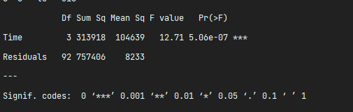

* The pp**-value** (read from the Pr(>F) column) is almost 0, which is much less than 0.05, so we reject H0. That is, we have enough evidence to conclude that there is a statistically significant difference between groups
* The significant result tells us that at least one of the groups is significantly different from the others, but it does not tell us which group(s), or how many. We will carry out pot-hoc tests later for further analysis
* The test statistic (F value) is F=12.71
* d1=3 (read from the Df column, time row)
* d2=92 (read from the Df column, Residuals  row)
* To summarise, we can write: There was a significant difference in mean flipper length [F(3, 92) = 12.71, p<.001] between time range.